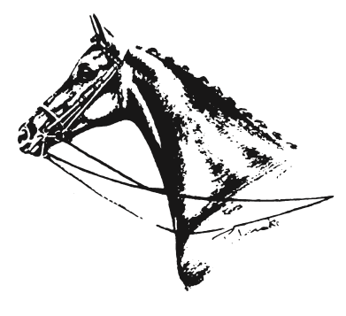
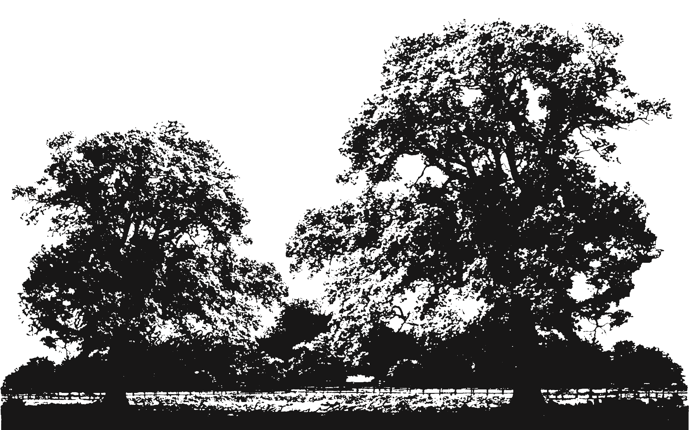
British Show Pony Society
AREA

15
A
HERTFORDSHIRE and MIDDLESEX
PRESENTS

The Mid-Herts
Country Show

To be held on
SUNDAY 22nd JULY 2018
at
THE COLLEGE EQUESTRIAN CENTRE, Church Road, Keysoe, Beds MK44 2JP
(For directions go to www.keysoe.com)

2018 QUALIFIERS FOR:
HORSE OF THE YEAR SHOW
OLYMPIA
BRITISH SHOW PONY SOCIETY CHAMPIONSHIPS (Affiliation No. 82/18)
BSHA NATIONAL CHAMPIONSHIPS
EQUIFEST
TSR
2019 QUALIFIERS FOR:
RIHS BSPA COLOUREDS
TATTERSALLS RoR

ENTRIES SECRETARY: Mrs B Davis, Oakdene, Springwell Lane, Harefield, Middlesex UB9 6PG

ENTRIES CLOSE: FRIDAY 13th JULY 2018
Late entries and entries taken on the day at extra cost.

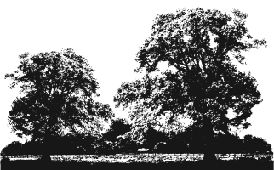
B.S.P.S. AREA 15A

President Mr Terry Hepple
Chairman Miss Lucinda Haines
Vice Chairman, Secretary & Show Director Mrs Victoria Clark
The Mid-Herts Country Show
Entries Secretary Mrs Barbara Davis
Cups & Trophies Mrs Linda Haines & Miss Lucinda Haines
Trade Stands & Sponsors Mrs Michelle Baxter-Davis
Steward Co-ordinators Mrs Victoria Clark & Miss Sofie Carter
Treasurer Mrs Serena Flynn
Show Committee Miss Hannah Carter, Mrs Juliet Collins, Miss Emma Jayne Holder, Mrs Gayle Holder, Mrs Sarah Ready, Mrs Emily Whalley

JUDGES
___________________________________________________________________________________________________________
HORSE OF THE YEAR SHOW The Price Family Lead Rein & First Ridden Mrs K Iggulden
Novice and Pretty Polly Show Ponies and Show Hunter Ponies
___________________________________________________________________________________________________________
HORSE OF THE YEAR SHOW The Baker – Beall Family Intermediate Show Riding Type Miss S Chapman (S) &
& Intermediate Show Hunter Type Mr P Hilton (C) ___________________________________________________________________________________________________________
HORSE OF THE YEAR SHOW The Binks Family Show Hunter Ponies Mrs H Buchanan (S) &
HORSE OF THE YEAR SHOW Lead Rein of Show Hunter Type Mrs C Whiteley (C)
___________________________________________________________________________________________________________
OLYMPIA BSPS Heritage Ridden M&Ms Mrs R Newman (S) & Mrs V Clark (C)
___________________________________________________________________________________________________________
HORSE OF THE YEAR SHOW Colne M&M Lead Rein Miss A Grummitt (S) &
& Brineton Kare-Plus M&M First Ridden Miss J Grummitt (C)
___________________________________________________________________________________________________________
HORSE OF THE YEAR SHOW Brereton Small Hack & David Stennett Ltd Large Hack
HORSE OF THE YEAR SHOW Topham Barnes Small & Large Riding Horse Miss M Richardson (R)
HORSE OF THE YEAR SHOW The Colosso Family Lightweight & Heavyweight Cob Mr M Jones (C)
Open Maxi Cob
___________________________________________________________________________________________________________
Novice & Amateur Riding Horse, Cobs and Hacks Miss N Graylen (R) & Mrs J Jenkins (C)
___________________________________________________________________________________________________________
RIHS 2019 BSPA Coloured Classes Mrs W King
___________________________________________________________________________________________________________
Novice Intermediate, Novice & Pretty Polly Show Hunter Pony Miss S Chapman
___________________________________________________________________________________________________________
Show Ponies Miss A Grummitt
___________________________________________________________________________________________________________
Pretty Polly Lead Rein & First Ridden Mr P Hilton
___________________________________________________________________________________________________________
Tiny Tots Lead Rein & First Ridden Mrs C Whiteley
___________________________________________________________________________________________________________
Novice & Pretty Polly Heritage Ridden M&Ms Miss J Grummitt
___________________________________________________________________________________________________________
RoR Tattersalls 2019 Qualifier and RoR In Hand Mrs D Newman
___________________________________________________________________________________________________________

Mid-Herts Country Show 2018 – Timetable

The Bedkind Ring | The Cohort Security Ring | The Team Holder Ring | The Barkway Stud Ring | The LP Pallett Group Ring
8.30am | 8am | 8.30am | 8.30am | 10am
Judge: S Chapman | Judges: N Graylen / J Jenkins | Judge: K Iggulden | Judges: H Buchanan / C Whiteley | Judge: J Grummitt
1. Novice Int | 11. Novice Cob | 24. Novice SP | 35. HOYS LR SHT | 44. Novice Small Breeds
Judges: S Chapman / P Hilton | 12. Amateur Cob | 25. Pretty Polly SP |  | 45. Novice Large Breeds
2. HOYS Int SHT | Judges: M Richardson / M Jones |  | Judge: C Whiteley | 46. Pretty Polly M&M
3. HOYS Int SRT 153cm | 13. HOYS LWT Cob | Judge: A Grummitt | 36. Tiny Tots LR
4. HOYS Int SRT 158cm | 14. HOYS HWT Cob | 26. 128cm SP | 37. Tiny Tots FR | Not before 11.30am
Int Ch / 15a Int Ch | 15. Maxi Cob | 27. 138cm SP | Tiny Tots Ch / 15a Tiny Tots Ch | Judges: R Newman / V Clark
 | Cob Ch | 28. 148cm SP |  | 47. Olympia Small Breeds
Not before 11.30am |  | SP Ch / 15a SP Ch | Not before 10.30am | 48. Olympia A&Bs
Judge: S Chapman | Not before 11am |  | Judge: K Iggulden | 49. Olympia Cs
5. Novice SHP | Judges: N Graylen / J Jenkins | Not before 11am | 38. HOYS LR | 50. Olympia Ds
6. Pretty Polly SHP | 16. Novice RH | Judge: D Newman | 39. HOYS FR | 51. Olympia Large Breeds
 | 17. Amateur RH | 29. RoR In Hand | Mini Ch | 52. Olympia NF & Connemara
Not before 12.30pm | Judges: M Richardson / M Jones | 30. RoR Tattersalls Ridden Qualifier |  | Olympia Ch / 15a M&M Ch
Judges: H Buchanan / C Whiteley | 18. HOYS Small RH |  | Not before 12.30pm
7. HOYS 122cm SHP | 19. HOYS Large RH | Not before 12.30pm | Judge: P Hilton
8. HOYS 133cm SHP | RH Ch | Judges: W King | 40. Pretty Polly LR
9. HOYS 143cm SHP |  | 31. RIHS BSPA Native Horse | 41. Pretty Polly FR
10. HOYS 153cm SHP | Not before 1.30pm | 32. RIHS BSPA Native Pony | Pretty Polly Ch / 15a Mini Ch
SHP Ch / 15a SHP Ch | Judges: N Graylen / J Jenkins | 33. RIHS BSPA Non-Native Horse
 | 20. Novice Hack | 34. RIHS BSPA Non-Native Pony | Not before 1.30pm
Area 15a Supreme Pony Ch | 21. Amateur Hack | BSPA Ch | Judges: A Grummitt / J Grummitt
Area 15a Supreme Horse Ch | Judges: M Richardson / M Jones |  | 42. HOYS M&M LR
 | 22. HOYS Small Hack |  | 43. HOYS M&M FR
 | 23. HOYS Large Hack |  | Mini M&M Ch / 15a Mini M&M Ch
 | Hack Ch

RI THE BEDKIND RING

8.30am PROMPT
NG 1
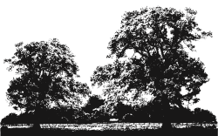
RING 1

Class 1 BSPS NOVICE INTERMEDIATE SHOW RIDING/HUNTER TYPE
Mare or gelding 4 years old or over exceeding 146cms but not exceeding 158cms, suitable to be ridden by a rider not to have attained their 25th birthday before 1st January in the current year. To be shown in a snaffle bridle.
Kindly sponsored by the Julie Farel and Stacey Millsom

Class 2 BSPS INTERMEDIATE SHOW HUNTER TYPE (Horse of the Year Show Qualiﬁer 2018)
Mare or gelding 4 years old or over exceeding 148cms but not exceeding 158cms, suitable to be ridden by a rider not to have attained their 25th birthday before 1st January in the current year. Please read the rules regarding membership stipulations for this class at www.hoys.co.uk.
THE COURTLANDS ARISTOCRAT CUP presented by Mrs M Francis & Mrs V J Pickford

Class 3 153cm INTERMEDIATE SHOW RIDING TYPE (Horse of the Year Show Qualiﬁer 2018)
Mare or gelding 4 years old or over exceeding 146cms but not exceeding 153cms, suitable to be ridden by a rider not to have attained their 25th birthday before 1st January in the current year. Please read the rules regarding membership stipulations for this class at www.hoys.co.uk.
THE KEELBY EASTER PARADE CUP presented by Miss Emily Curtis

Class 4 158cm INTERMEDIATE SHOW RIDING TYPE (Horse of the Year Show Qualiﬁer 2018)
Mare or gelding 4 years old or over exceeding 153cms but not exceeding 158cms, suitable to be ridden by a rider not to have attained their 25th birthday before 1st January in the current year. Please read the rules regarding membership stipulations for this class at www.hoys.co.uk.
THE CONSTELLATION CUP presented by Lady Hedgerley

INTERMEDIATE CHAMPIONSHIP 1st and 2nd prize winners from classes 1–4 to compete.
The Champion to qualify for the BSPS Binks Family Champion of Champions
THE TWINKLE TROPHY presented by Miss Lucinda Haines

BSPS AREA 15A INTERMEDIATE CHAMPIONSHIP The two highest placed ponies from classes 1-4 owned and ridden by a member of BSPS Area 15A to compete.
THE MAURA SYKES BRENNAN MEMORIAL TROPHY presented by Dr & Mrs Brennan
THE CHAMPION AND RESERVE TO COMPETE FOR THE BSPS AREA 15A SUPREME PONY CHAMPIONSHIP

NOT BEFORE 11.30am

Class 5 BSPS MIXED HEIGHT NOVICE SHOW HUNTER PONY
Mare or gelding 4 years old or over not exceeding 153cms. Riders MUST be the correct age for the height of pony they ride.
THE IMPULSE CUP presented by Mrs H Sleight

Class 6 BSPS PRETTY POLLY MIXED HEIGHT SHOW HUNTER PONY (Home Produced)
Mare or gelding 4 years old or over not exceeding 153cms. Riders MUST be the correct age for the height of the animal they ride.
THE BUSTER TROPHY presented by Mrs J K Reed

NOT BEFORE 12.30pm

Class 7 The Binks Family 122cm SHOW HUNTER PONY (Horse of the Year Show Qualiﬁer 2018)
Mare or Gelding 4 years old or not exceeding 122cms, suitable to be ridden by a rider not to have attained their 12th birthday before 1st January in the current year. Please read the rules regarding membership stipulations for this class at www.hoys.co.uk.
THE PEBBLY PEPPERPOT CUP presented by Mrs Kati Choynowski

Class 8 The Binks Family 133cm SHOW HUNTER PONY (Horse of the Year Show Qualiﬁer 2018)
Mare or Gelding 4 years old or over exceeding 122cms but not exceeding 133cms, suitable to be ridden by a rider not to have attained their 14th birthday before 1st January in the current year. Please read the rules regarding membership stipulations for this class at www.hoys.co.uk.
THE BENEDICT SALVER presented by Mrs Sue Worthington
Kindly sponsored by the Jackson-Clutton Family

Class 9 The Binks Family 143cm SHOW HUNTER PONY (Horse of the Year Show Qualiﬁer 2018)
Mare or Gelding 4 years old or over exceeding 133cms but not exceeding 143cms, suitable to be ridden by a rider not to have attained their 17th birthday before 1st January in the current year. Please read the rules regarding membership stipulations for this class at www.hoys.co.uk.
THE STAMBROOK PORTIA SALVER presented by Miss Katie Davis

Class 10 The Binks Family 153cm SHOW HUNTER PONY (Horse of the Year Show Qualiﬁer 2018)
Mare or Gelding 4 years old or over exceeding 143cms but not exceeding 153cms, suitable to be ridden by a rider not to have attained their 20th birthday before 1st January in the current year. Please read the rules regarding membership stipulations for this class at www.hoys.co.uk.
THE WINTERS TALE CUP presented by The Morrison Family
Kindly sponsored by Mrs Park-Ross

OPEN SHOW HUNTER PONY CHAMPIONSHIP 1st and 2nd prize winners from classes 7-10 to compete.
THE MAGIC CUP presented by Mrs D Hind
The Champion to qualify for the BSPS Binks Family Champion of Champions

BSPS AREA 15A SHOW HUNTER PONY CHAMPIONSHIP The two highest placed ponies from classes 5-10 owned and ridden by a member of BSPS Area 15A to compete.
THE KELMANSON CUP presented by the Kelmanson Family
THE CHAMPION AND RESERVE TO COMPETE FOR THE BSPS AREA 15A SUPREME PONY CHAMPIONSHIP

BSPS AREA 15A ‘PAT MONAGHAN’ SUPREME PONY CHAMPIONSHIP All BSPS Area 15A Champion and Reserve Champions to compete. Champion will qualify for the BSPS 'Best of the Best' Supreme Championship at the BSPS Summer Championships 2016 offering over £1000 in prize money.
Supreme: THE PAT MONAGHAN MEMORIAL TROPHY presented by the Monaghan Family
Reserve Supreme: THE RAY FORSTER MEMORIAL TROPHY
Flower Sashes to be presented to the champion and reserve, kindly sponsored by Jane Evans
The champion will receive a woollen day rug– kindly sponsored by Equiporium (www.equiporium.co.uk)

BSPS AREA 15A 'DAVID CURTIS' SUPREME HORSE CHAMPIONSHIP Open to the 2 highest placed horses owned and ridden by BSPS Area 15A members from each of the ridden horse classes (11-23).
Supreme: THE DAVID CURTIS MEMORIAL TROPHY presented by BSPS Area 15a
Reserve Supreme: THE HONEY GLIDER CUP presented by Miss Julie Farrell
Flower Sashes to be presented to the champion and reserve, kindly sponsored by DMSL Broadband and Phones
The champion will receive a woollen day rug– kindly sponsored by Equiporium (www.equiporium.co.uk)

RING 2
THE COHORT SECURITY RING

8am PROMPT

All classes in this ring run under British Show Horse Association rules – please refer to BSHA section at back of schedule

BSPS Area 15a Supreme Horse Championship
The 2 highest placed horses owned and ridden by a member of BSPS Area 15A competing in classes 11-23 will be eligible for the BSPS Area 15a 'David Curtis' Supreme Horse Championship to be held in Ring 1 at the end of the day. Please ensure you wear a RED ARMBAND in your class to qualify.
Class 11 NOVICE RIDDEN COB
Mare or gelding, 4 years and over exceeding 148cms. Please refer to BSHA Rule Book 2018 Novice Rule 7E

Class 12 AMATEUR OWNER/RIDER COB
Mare or gelding, 4 years and over exceeding 148cms. Please refer to BSHA Rule Book 2018 Amateur Rule 7A-C.

Class 13 The Colosso Family LIGHTWEIGHT COB (Horse of the Year Show Qualiﬁer 2018)
Mare or gelding 4 years and over, capable of carrying up to 14 stone, exceeding 148cms but not exceeding 155cms. Please read the rules regarding membership stipulations for this class at www.hoys.co.uk.

Class 14 The Colosso Family HEAVYWEIGHT COB (Horse of the Year Show Qualiﬁer 2018)
Mare or gelding 4 years and over, capable of carrying more than 14 stone, exceeding 148cms but not exceeding 155cms. Please read the rules regarding membership stipulations for this class at www.hoys.co.uk.

Class 15 MAXI COB
Mare or gelding 4 years and over exceeding 155cms. Exhibits are shown hogged. A special rosette presented by www.theirishhorse.co.uk will be awarded to the Maxi Cob who has not previously won this award during the current season.

COB CHAMPIONSHIP 1st & 2nd prize winners from classes 11-15 to compete.
THE BALLYKNOCKEN CUP presented by Mrs Judy Howell
Kindly sponsored by Jobling Purser Ltd

NOT BEFORE 11am

Class 16 NOVICE RIDING HORSE
Mare or gelding 4 years old or over exceeding 148cms. Please refer to BSHA Rule Book 2018 Novice Rule 7E
THE LONDON SPLENDOUR CUP presented by Messrs Johnson & King

Class 17 AMATEUR OWNER/RIDER RIDING HORSE
Mare or gelding 4 years old or over exceeding 148cms. Please refer to BSHA Rule Book 2018 Amateur Rule 7A-C.

Class 18 The Topham Barnes SMALL RIDING HORSE (Horse of the Year Show Qualiﬁer 2018)
Mare or gelding 4 years old or over exceeding 148cms but not exceeding 158cms. Please read the rules regarding membership stipulations for this class at www.hoys.co.uk.
THE H J SMITH MEMORIAL TROPHY presented by Mrs M Francis
Kindly sponsored by Lincs Forage

Class 19 The Topham Barnes LARGE RIDING HORSE (Horse of the Year Show Qualiﬁer 2018)
Mare or gelding 4 years old or over exceeding 158cms. Please read the rules regarding membership stipulations for this class at www.hoys.co.uk.

RIDING HORSE CHAMPIONSHIP 1st & 2nd prize winners from classes 16-19 to compete.
THE PALACE FROLIC TROPHY presented by Mrs A Smyth

NOT BEFORE 1.30pm

Class 20 NOVICE HACK
Mare or gelding, 4 years old or over exceeding 148cms but not exceeding 160cms. Please refer to BSHA Rule Book 2018 Novice Rule 7E
THE PHIL PEARL CUP presented by Messrs Johnson & King

Class 21 AMATEUR OWNER/RIDER HACK
Mare or gelding, 4 years old or over exceeding 148cms but not exceeding 160cms. Please refer to BSHA Rule Book 2018 Amateur Rule 7A-C.

Class 22 Brereton SMALL HACK (Horse of the Year Show Qualiﬁer 2018)
Mare or gelding, 4 years old or over exceeding 148cms but not exceeding 154cms. Please read the rules regarding membership stipulations for this class at www.hoys.co.uk.
THE LIMITED EDITION CUP presented by Mrs J Offers

Class 23 David Stennett Ltd. LARGE HACK (Horse of the Year Show Qualiﬁer 2018)
Mare or gelding, 4 years old or over exceeding 154cms but not exceeding 160cms. Please read the rules regarding membership stipulations for this class at www.hoys.co.uk.
THE LORD GUY CUP presented by Mr & Mrs D Curtis
Kindly sponsored by Ann and Ed Sykes-Brennan

HACK CHAMPIONSHIP 1st and 2nd prize winners from classes 20-23 to compete.
THE TOM PALMER TROPHY presented by Miss Hetherington
RI

8.30am PROMPT
NG 1
RING 3

THE TEAM HOLDER RING

8.30am PROMPT

Class 24 BSPS MIXED HEIGHT NOVICE SHOW PONY
Mare or gelding 4 years old or over not exceeding 148cms. Riders MUST be the correct age for the height of pony they ride.
THE ANTHONY DOUGLAS EATON MEMORIAL TROPHY presented by Mrs S Brewis
Kindly sponsored by Mrs K Rogers

Class 25 BSPS PRETTY POLLY MIXED HEIGHT SHOW PONY (Home Produced)
Mare or gelding 4 years old or over not exceeding 148cms. Riders MUST be the correct age for the height of the pony they ride.
THE HIGHCLERE TROPHY presented by Mrs J K Reed
Kindly sponsored by Tracey Hulatt

Class 26 BSPS 128cm SHOW PONY
Mare or gelding 4 years old or over not exceeding 128cms, suitable to be ridden by a rider not to have attained their 13th birthday before 1st January in the current year.
THE MIDAS CUP presented by The Young Family
Kindly sponsored by Snuggy Hoods Ltd

Class 27 BSPS 138cm SHOW PONY
Mare or gelding 4 years old or over exceeding 128cms but not exceeding 138cms, suitable to be ridden by a rider not to have attained their 15th birthday before 1st January in the current year.
THE SKIPPY SHIELD presented by The Monaghan Family
Kindly sponsored by Snuggy Hoods Ltd

Class 28 BSPS 148cm SHOW PONY
Mare or gelding 4 years old or over exceeding 138cms but not exceeding 148cms, suitable to be ridden by a rider not to have attained their 17th birthday before 1st January in the current year.
THE REED CUP presented by Mrs J Reed
Kindly sponsored by Snuggy Hoods Ltd

OPEN SHOW PONY CHAMPIONSHIP 1st and 2nd prize winners from classes 26-28 to compete.
THE ALEXANDER CUP presented by Mr A Rodrigues
The Champion to qualify for the BSPS Binks Family Champion of Champions
Kindly sponsored by Snuggy Hoods Ltd - £40 voucher to the Champion SP, £20 voucher to the Reserve Champion

BSPS AREA 15A SHOW PONY CHAMPIONSHIP The two highest placed ponies from classes 24-28, owned and ridden by a member of BSPS Area 15A to compete.
THE LUCINDA CUP presented by Miss L Haines
THE CHAMPION AND RESERVE TO COMPETE FOR THE BSPS AREA 15A SUPREME PONY CHAMPIONSHIP
Kindly sponsored by Snuggy Hoods Ltd - £40 voucher to the Champion SP, £20 voucher to the Reserve Champion

NOT BEFORE 11am

Class 29 RoR OPEN IN-HAND SHOW SERIES QUALIFIER
Open to all RoR and NR registered horses, 3yrs and over, fillies, mares and geldings.
Blemishes caused through racing will be ignored.
This class is a qualifier for the RoR OPEN In Hand Showing Series FINAL. The first three go forward to the final at the RoR Championships, Aintree in August 2018.

Class 30 RoR TATTERSALLS THOROUGHBRED RIDDN SHOW SERIES QUALIFIER 2019
Thoroughbred mare or gelding, 4years old or over, any height. Riders must be 15 years or over. Horses should be ridden in a snaffle, pelham or simple double bridle. Horses should be plaited. The first TWO go forward to the championship in 2019. All entries MUST be registered with the RoR and include their registration number on entry form and have RACED in GB. All those entering horses and/or participating in the show agree to be bound by the Retraining of Racehorses Rules and Regulations from time to time in force’
There will be a prize for the highest places horse that is ridden by an Amateur.
Please be aware that the show will split the class on the horse’s last run in a race (NH or Flat) or will provide 2 ride judges should the entries exceed 20. Please mark your entry form accordingly. Competitors must wear a safety/kite mark hard hat with a chinstrap.
Racing injuries and blemishes will NOT be ignored in this series
Prizes : Rosettes 1st - 6th and Vouchers 1st to 4th place. Veteran prize (15+) - £25 voucher to be redeemed from RoR office and qualification for the Veteran Final at the RoR Championships at Aintree.

NOT BEFORE 12.30pm

Class 31 BSPA RIDDEN HORSES EXC 153CM TRADITIONAL AND NATIVE TYPE (2019 RIHS Qualifier)
Stallion, mare or gelding, 4 years old and over exceeding 153cm to be shown in their natural state or hogged. Judge will ride.

Class 32 BSPA RIDDEN PONIES NOT EXC 153CM TRADITIONAL AND NATIVE TYPE (2019 RIHS Qualifier)
Stallion, mare or gelding, 4 years old and over not exceeding 153cm to be shown in their natural state or hogged. Judge will not ride. Display required. No spurs to be worn. No leading reins permitted.

Class 33 BSPA RIDDEN HORSES EXC 153CM PLAITED (2019 RIHS Qualifier)
Stallion, mare or gelding, 4 years old and over exceeding 153cm. Judge will ride.
Class 34 BSPA RIDDEN PONIES NOT EXC 153CM PLAITED (2019 RIHS Qualifier)
Stallion, mare or gelding, 4 years old and over not exceeding 153cm. Judge will not ride. Display required. No spurs to be worn. No leading reins permitted.

BSPA COLOURED CHAMPIONSHIP Open to 1st and 2nd prize winners from classes 31 – 34
THE TC FEEDS & TACK HAVEN PERPETUAL TROPHY presented by TC Feeds

THE BARKWAY STUD RING

8.30am PROMPT
NG 1
RING 4

Class 35 LEAD REIN PONY OF HUNTER TYPE (Horse of the Year Show Qualiﬁer 2018)
Mare or Gelding 4 years old or over not exceeding 122cms. Riders must have attained their 3rd birthday by the day of competition but not attained their 9th birthday before 1st January in the current year. Competitors will be required to negotiate obstacles during their individual show in this class.
THE MAPLE CHALLENGE SHIELD presented by Mrs K Dummer
Kindly sponsored by Harvey and Matilda Masters
The highest placed pony owned and ridden by a member of BSPS Area 15a to compete for the BSPS AREA 15A SUPREME PONY CHAMPIONSHIP

Class 36 TINY TOTS LEAD REIN
Mare or gelding 4 years old or over not exceeding 122cms, suitable to be ridden by a rider not to have attained their 6th birthday before 1st January in the current year. Open to SP, SHP, M&M, not required to be plaited. This class will be judged on the suitability of the pony to introduce a child to the show ring.
THE ROSCOILL LEGACY CUP presented by Mrs M R Cole
Kindly sponsored by Lisa Street

Class 37 TINY TOTS FIRST RIDDEN
Mare or gelding 4 years old or over not exceeding 122cms, suitable to be ridden by a rider not to have attained their 9th birthday before 1st January in the current year. Open to SP, SHP, M&M, not required to be plaited. This class will be judged on the suitability of the pony to introduce a child to the show ring.
THE STACEY CHALLENGE CUP
Kindly sponsored by Tracey Hulatt

TINY TOTS CHAMPIONSHIP 1st and 2nd prize winners from classes 36 & 37 to compete.
THE POPPY CUP presented by The Baxter-Davies family
Flower sashes to the champion and reserve, kindly sponsored by Rapid Search & Interim

BSPS AREA 15A TINY TOTS CHAMPIONSHIP The two highest placed ponies from classes 36 & 37 owned and ridden by a member of BSPS Area 15A to compete.
THE GREENACRES BRIGHTLIGHTS CUP presented by Mrs B and Miss K Davis
THE CHAMPION AND RESERVE TO COMPETE FOR THE BSPS AREA 15A SUPREME PONY CHAMPIONSHIP

NOT BEFORE 10.30am

Class 38 The Price Family LEAD REIN (Horse of the Year Show Qualiﬁer 2018)
Mare or gelding 4 years old or over not exceeding 122cms, suitable to be ridden by a rider not to have attained their 8th birthday before 1st January in the current year. Please read the rules regarding membership stipulations for this class at www.hoys.co.uk.
THE BARKWAY BRIDESMAID CUP presented by Team Holder

Class 39 The Price Family FIRST RIDDEN (Horse of the Year Show Qualiﬁer 2018)
Mare or gelding 4 years old or over not exceeding 122cms, suitable to be ridden by a rider not to have attained their 10th birthday before 1st January in the current year. Please read the rules regarding membership stipulations for this class at www.hoys.co.uk.
THE PEARLS NOBLE KNIGHT CUP presented by Messrs Johnson & King
Kindly sponsored by Hep Oils

OPEN MINI CHAMPIONSHIP 1st and 2nd prize winners from classes 38 & 39 to compete.
THE LITTLE CUP presented by Cathy Sharman
The Champion to qualify for the BSPS Binks Family Champion of Champions
Flower sashes to the champion and reserve, kindly sponsored by Rapid Search & Interim

NOT BEFORE 12.30pm

Class 40 BSPS PRETTY POLLY LEADING REIN PONY (Home Produced)
Mare or gelding 4 years old or over not exceeding 122cms, suitable to be ridden by a rider not to have attained their 9th birthday before 1st January in the current year. Open to SP, SHP, M&M, not required to be plaited.
THE BUBBLES CUP presented by Messrs Johnson & King
Kindly sponsored by The Ready Family

Class 41 BSPS PRETTY POLLY FIRST RIDDEN PONY (Home Produced)
Mare or gelding 4 years old or over not exceeding 122cms, suitable to be ridden by a rider not to have attained their 11th birthday before 1st January in the current year. Open to SP, SHP, M&M, not required to be plaited.
THE DUSTER TROPHY presented by Mrs J Reed
Kindly sponsored by Mrs M Shoolheifer

PRETTY POLLY MINI CHAMPIONSHIP 1st and 2nd prize winners from classes 40 and 41 to compete.
THE RIDE-A-WAY CUP presented by Messrs Johnson & King

BSPS AREA 15A MINI CHAMPIONSHIP The two highest placed ponies from classes 38 - 41 ridden and owned by a member of BSPS Area 15A to compete.
THE DEVON MAZURKA SHIELD presented by Mrs M Dent
Kindly sponsored by Diane Mindel at the Newtonhill Stud
THE CHAMPION AND RESERVE TO COMPETE FOR THE BSPS AREA 15A SUPREME PONY CHAMPIONSHIP

NOT BEFORE 1.30pm

Class 42 Colne M&M LEAD REIN (Horse of the Year Show Qualiﬁer 2018)
Mare or gelding 4 years old or over, not exceeding 122cms, suitable to be ridden by a rider not to have attained their 9th birthday before 1st January in the current year. To be led by an attendant and shown in a snaffle bridle with the lead rein attached to the noseband only. Please read the rules regarding membership stipulations for this class at www.hoys.co.uk.
THE STANMORE CUP presented by Messrs Johnson & King

Class 43 Brineton / Kare-Plus M&M FIRST RIDDEN (Horse of the Year Show Qualiﬁer 2018)
Mare or gelding 4 years old or over, not exceeding 128cms, suitable to be ridden by a rider not to have attained their 12th birthday before 1st January in the current year. Please read the rules regarding membership stipulations for this class at www.hoys.co.uk.
THE BRADMORE CUP

HERITAGE MINI CHAMPIONSHIP 1st and 2nd prize winners from classes 42 & 43 to compete.
THE FOXTROT GEMMA CUP presented by the Harrison-Marlow Family
Flower sashes to the champion and reserve, kindly sponsored by Ison Travel

BSPS AREA 15A HERITAGE MINI CHAMPIONSHIP The two highest placed ponies from classes 42 & 43 owned and ridden by a member of BSPS Area 15A to compete.
THE HUGH VIGUS MEMORIAL CUP presented by Cathy Sharman
THE CHAMPION AND RESERVE TO COMPETE FOR THE BSPS AREA 15A SUPREME PONY CHAMPIONSHIP

RING 5
THE LP PALLETT GROUP RING

10am PROMPT
NG 1

Class 44 BSPS HERITAGE M&M NOVICE RIDDEN SMALL BREEDS
Open to registered pure bred Welsh Section A, Welsh Section B, Dartmoor, Exmoor and Shetland ponies 4 years old or over. Riders any age.
THE KATOFELTO TANKARD presented by The Evans Family

Class 45 BSPS HERITAGE M&M NOVICE RIDDEN LARGE BREEDS
Open to registered pure bred Welsh Section C, Welsh Section D, Highland, Dale, Fell, Connemara and New Forest ponies 4 years old and over. Riders any age.
THE STALWART TANKARD presented by The Evans Family

Class 46 BSPS HERITAGE PRETTY POLLY M&M MIXED BREEDS (Home Produced)
Open to registered pure bred ponies 4 years old or over. Riders any age.
THE MANTON SHIELD presented by Mr & Mrs P Garland.

NOT BEFORE 11.30am

The winners of classes 47-52, with the exception of the pony that qualifies for Olympia, will qualify to compete at the semi-final to be held at BSPS HERITAGE CHAMPIONSHIP SHOW, at Arena UK (qualification will not pass down the line).

Class 47 THE LEMIEUX NATIVE BSPS CHAMPIONSHIP OPEN RIDDEN SMALL BREEDS
Open to registered pure bred Dartmoor, Exmoor and Shetland ponies 4 years old or over. Riders any age

Class 48 THE LEMIEUX NATIVE BSPS CHAMPIONSHIP OPEN RIDDEN WELSH SECTION A/B
Open to registered pure bred Welsh Section A and B ponies 4 years old or over. Riders any age

Class 49 THE LEMIEUX NATIVE BSPS CHAMPIONSHIP OPEN RIDDEN WELSH SECTION C
Open to registered pure bred Welsh Section C ponies 4 years old or over. Riders any age

Class 50 THE LEMIEUX NATIVE BSPS CHAMPIONSHIP OPEN RIDDEN WELSH SECTION D
Open to registered pure bred Welsh Section D ponies 4 years old or over. Riders any age

Class 51 THE LEMIEUX NATIVE BSPS CHAMPIONSHIP OPEN RIDDEN LARGE BREEDS
Open to registered pure bred Highland, Dale and Fell ponies 4 years old or over. Riders any age

Class 52 THE LEMIEUX NATIVE BSPS CHAMPIONSHIP OPEN RIDDEN CONNEMARA & NEW FOREST
Open to registered pure bred Connemara and New Forest ponies 4 years old or over. Riders any age

THE LEMIEUX NATIVE BSPS OPEN RIDDEN CHAMPIONSHIP 1st and 2nd prize winners from classes 47-52 to compete. The Champion to qualify for OLYMPIA 2018. If the Champion has already qualified, the qualification will be awarded to the Reserve Champion. If the Champion and Reserve have qualified the third placed pony will qualify.
Flower sashes to the champion and reserve, kindly sponsored by Saunters Plant Hire

BSPS AREA 15A HERITAGE RIDDEN CHAMPIONSHIP The two highest placed ponies from classes 44-52 owned and ridden by a member of BSPS Area 15A to compete.
THE LP GROUP CHALLENGE TROPHY presented by Mr & Mrs Pallett
THE CHAMPION AND RESERVE TO COMPETE FOR THE BSPS AREA 15A SUPREME PONY CHAMPIONSHIP

ENTRY FEES

Horse of the Year Show qualifiers: £36 (Entry fee includes £12 Horse of the Year Show contribution)
ALL HOYS ENTRIES MUST BE ACCOMPANIED BY A HORSE OF THE YEAR SHOW ENTRY FORM
RIHS 2019 and Olympia qualifiers: £30
All other classes: £15

ENTRIES CLOSE 10TH JULY 2018
Late entries and entries on the day = Horse of the Year Show: £50; RIHS and Olympia £40; All other classes: £20
ENTER ONLINE AT www.bspsarea15a.entrymaster.net

ALL POSTAL ENTRIES TO:
Mrs B Davis, Oakdene, Springwell Lane, Harefleld, Middlesex. UB9 6PG
Tel: 01895 823576 Mobile: 07960 639577 Email: bedavis444@gmail.com
NO PHONE CALLS AFTER 9.00 PM
Cheques should be made payable to BSPS Area 15A. Returned cheques will be charged £10
PRIZE MONEY
HOYS qualifiers: 1st: £35 2nd: £20 3rd: £15
RIHS 2019 and Olympia qualifiers: 1st: £30 2nd: £15 3rd: £10
All other classes: 1st: £15
In the event of there being less than 5 entries in a class, only the 1st prize money will be given.
All prize money to be collected from the Secretary on the day.

STABLING
Stabling is available on the showground. Please contact The College EC directly on 01234 708400

RULES AND CONDITIONS OF ENTRY
- The organising committee does not accept any liability for accident, damage, injury or illness to horse, owners, riders, spectators, or any other
- person or property. Any accident must be reported to a Show official as soon as possible. First Aiders will be on duty for all classes.
- All horses and ponies must be 4yrs old or over
- Any horse/pony which is not under complete control or in any way constitutes a danger will be asked to leave the show ground.
- Absolutely no nomination or substitution entries will be permitted.
- No entry fee will be refunded.
- The Secretary reserves the right to refuse any entry at the absolute discretion of the BSPS Area 15A committee.
- The committee reserve the right to alter the times of classes or the Judge if necessary.
- All objections must be submitted in writing within 30 minutes of the completion of the class to the secretary with a deposit of £40.00
- Area rosettes will be presented to the highest placed pony owned and ridden by a member of BSPS Area 15A. Area members must wear RED ARMBANDS.
- Any cups or trophies won at the show must be returned 3 WEEKS PRIOR to the next show.
- Mucking out on the showground is forbidden.
- All dogs must be kept on leads and dog owners must pick up after their dogs.

BRITISH SHOW PONY SOCIETY: This show is affiliated to the British Show Pony Society (BSPS) and all persons entering, competing, showing or otherwise taking part in BSPS classes, whether or not members of the BSPS are subject to the Constitution and Rules of the BSPS, including disciplinary procedures and shall be deemed to have consented to the jurisdiction of the BSPS.
This show is a qualifier for the 2018 BSPS Summer Championships Show to be held at Arena UK on 22nd-25th August 2018. The 1st and 2nd placed ponies in classes 7-10, 26-28, 38 and 39, 1st, 2nd and 3rd placed ponies in classes 2-4 will qualify for the BSPS Summer Championships Show providing the animal is registered in accordance with Rules 23 and 28 and ridden by a BSPS member.
HORSE OF THE YEAR SHOW QUALIFIERS: This is a qualifying show for Horse of the Year Show, NEC, Birmingham, Wednesday 3rd to Sunday 7th October 2018. These classes will be run in accordance with the general rules as set out in the Horse of the Year Show rulebook, a copy of which can be downloaded from www.hoys.co.uk.
All data given upon entry of Horse of the Year Show qualifying classes is provided to Grandstand Media Limited and stored on the Grandstand Entries System. For full policy details please visit www.grandstandentries.com .
One pony only qualiﬁes in each class. The highest placed pony in the ﬁrst 5 (not already qualiﬁed) in The Price Family Lead Rein Pony and First Ridden Pony of the Year, Lead Rein Pony of Hunter Type and in each of the Intermediate Show Riding Type of the Year, and The Binks Family Show Hunter Pony of the Year classes will qualify. The highest placed pony in the ﬁrst 3 (not already qualiﬁed) in Colne M&M Lead Rein and Brineton/Kare-Plus M&M First Ridden Pony of the Year classes will qualify.
In the case of equality, the pony with the highest Manners & Way of Going mark will be deemed the winner. If there still be equality at this point, then the judges’ decision will be final. Qualification will be verified by the Horse of the Year Show office.
For The Price Family Lead Rein Pony and First Ridden Pony of the Year, Intermediate Show Riding Type of the Year, the Lead Rein Pony of Hunter Type, The Binks Family Show Hunter Pony of the Year, ponies, owners and riders must be members of either BSPS, Ponies UK, The Showing Register or NPS to compete in HOYS qualifying classes. For Colne M&M Lead Rein and Brineton/Kare-Plus M&M First Ridden Pony of the Year classes. Riders and Owners must be members of their respective Breed Society, NPS, Ponies (UK), The Showing Register, or BSPS. Ponies must be registered in the main body of their respective Stud Books

BLUE RIBAND PONY OF THE YEAR: The 1st and 2nd placed ponies in the BSPS Lead Rein and First Ridden, Open Show Hunter Pony, Open Intermediate SRT and SHT qualifying classes will qualify. Owners and riders must be BSPS members and the pony registered with the BSPS to qualify for the Blue Riband.
THE BSPS CHALLENGE: This show is a qualifier for the BSPS Challenge for Open Lead Rein and First Ridden, Show Pony, Show Hunter Pony, Intermediate SRT and SHT, Heritage M&M Lead Rein and First Ridden and Heritage Open Ridden. Animals must qualify for the Challenge by attending any BSPS affiliated show and competing in the appropriate class. Ponies must not have qualified for the 2018 Horse of the Year Show in the appropriate class.
THE BSPS PREMIER LEAGUE COMPETITION: The 1st, 2nd, 3rd and 4th placed ponies in the Open Show Ponies will qualify.
THE BSPS ‘BLACK COUNTRY SADDLES’ BEST RIDER: The best rider in each of the BSPS Open Show Pony, Open Show Hunter Pony, Open Intermediate SRT and SHT, Lead Rein of Show Hunter Type, Leading Rein and First Ridden and Heritage Ridden classes will receive a card and qualify.
THE BSPS CHAMPION OF CHAMPIONS: The champion Mini Show Pony, Show Pony, Show Hunter Pony and Intermediate will qualify for the final at the BSPS Summer Championships Show.
THE HERITAGE WOW FACTOR: Ponies that have been placed 1st in open Heritage affiliated classes during the summer season will qualify for the “Winner of Winners” at the BSPS Summer Championships Show.

BRITISH SHOW HORSE ASSOCIATION: Classes 11-23 are held under the rules of the British Show Horse Association. Riders must be 15 years and older. Competitors and horses must be registered with the Association. Registration numbers must be quoted on entry form. Competitors in classes 11, 12, 15, 16, 17, 20 and 21 may enter with a Day Ticket.
DAY TICKETS: Non Members may purchase up to a maximum of 2 Day Tickets per exhibitor, per horse, per rider, per season. A Day Ticket will allow entry into Amateur, Home Produced, In-Hand, Novice, Working, Young Rider and Open affiliated classes only, but will NOT allow entry into RIHS or Horse of the Year Show qualifying classes. Horses registered on a Day Ticket do not require a JMB Height Certificate. Competitors can apply for a Day Ticket by downloading an application form from the BSHA website.
NOVICE RIDING HORSE/HACK/COB Mare or gelding 4 years old or over not to have won a first prize of £35 or more or more than a total of £250 in any showing classes which were affiliated to the Association, at home or abroad, prior to the 1 January 2018. Winnings gained as a four year old are excepted unless that four year old has won an Open Ridden class with a first prize of £35 or more. Animals which have been placed first at the RIHS or Horse of the Year Show in any ridden class are ineligible to compete. if the category has changed from a Hack to a Riding Horse, or vice versa, the horse may not revert back to a novice if it won a first prize of £35 or more, or more than a total of £250. A Novice may be shown in a snaffle bridle.
HORSE OF THE YEAR SHOW QUALIFIERS: Classes 13, 14, 18, 19, 22 and 23 are qualiﬁers for Horse of the Year Show NEC, Birmingham, Wednesday 3rd to Sunday 7th October 2018. Horses must be registered with the British Show Horse Association. All riders, owners and producers must be members of the British Show Horse Association.
These classes will be run in accordance with the general rules as set out in the Horse of the Year Show rulebook, a copy of which can be downloaded from www.hoys.co.uk. Horse of the Year Show rules will take precedence. The ﬁrst prize winner will qualify to compete at the ﬁnal. If already qualiﬁed the second will qualify, if the ﬁrst and second are already qualiﬁed then the third will go forward and so forth to ﬁfth place. Qualification will be verified by the Horse of the Year Show office.
All data given upon entry of Horse of the Year Show qualifying classes is provided to Grandstand Media Limited and stored on the Grandstand Entries System. For full policy details please visit www.grandstandentries.com .
In accordance with BSHA rules the annual BSHA Horse of the Year Show fee of £15 must have been paid to BSHA before the entry is made if the Exhibitor wishes to qualify. The BSHA Horse of the Year Show fee cannot be paid in retrospect. This fee is not the Horse of the Year Show contribution, which goes to Grandstand Media Ltd.
RISING STARS: Any Exhibitor placed in the first three in the Intermediate classes for Show Riding Type or Show Hunter Type may enter the Rising Stars class at the BSHA National Championship Show September 2018. No qualifying card is required.
CLASSIC SUPREME: The three highest placed horses in classes 13, 14, 15, 18, 19, 22 and 23 will qualify to compete in the BSHA Classic Supreme classes at the BSHA National Championships Show on 7th-9th September 2018.
The BSHA offer a Novice, Young Rider and Amateur rosette in each Open class and a Champion rosette for each section. The Association will also award an Amateur Home Produced rosette in Affiliated Open Cob classes (Light & Heavyweights only) - these rosettes have been kindly sponsored by TSG, Mr L Turley. The awards will go down the line; there is no limit on how many of these rosettes can be claimed in a year.

BSPA: Classes 31-34 are affiliated to the BSPA and are qualifiers for the RIHS 2019. Classes will be judged under BSPA rules – download from www.bspaonline.com. All horse/ponies, owners and riders must be registered with the BSPA prior to the show. Membership and qualification cards must be carried in the ring by competitors and produced as required for inspection or signature; no competitor/owner/horse may compete in these classes or enter the ring without a current 2018 membership and qualification card.
Spurs may not be worn in any pony class. Ponies 153cm or under (Shetlands exempt) must possess a current JMB height certificate.
All stallions must be graded with the BSPA and in possession of a BSPA stallion ID card which must be carried at all times and produced on request. All stallions must wear a blue 2018 BSPA stallion disc. No rider under 14 years of age may exhibit a stallion in any class. Rider age will be taken from 1st January.
The first placed and the next unqualified competitor standing 2nd or 3rd will qualify from each class. No competitor may qualify from lower than 3rd place.
The highest placed amateur and junior in each class will qualify for the amateur and junior supreme championship finals to be held at the BSPA World of Colour Championship Show on 15-16th September 2018 at the College EC, Keysoe, Beds. Qualification cards to be shown in the ring and signed.

EQUIFEST: The two highest placed exhibits not already qualified in classes 25-28, 31-34 and 46-52 will qualify for the relevant Equifest Championship, the finals to be held at the East of England Showground on 8th-12th August 2018. Qualification cards can be obtained from the secretaries.

THE SHOWING REGISTER: Classes 25-28, 31-34 and 46-52 are qualifiers for the 2018 TSR Showing Finals. Qualify and enter ANY of the Finals Central, East Anglia, North West, North East, South East, South, Wales & South West or Scottish. You Do Not have to be a TSR member to qualify or enter a final. The Rider/Handler qualifies and can enter any horse/pony in any number of Finals!
TSR Riders Finals - 1st & 2nd riders qualify and will receive a qualification card in the ring.
TSR In Hand Finals - The two highest placed Handlers with a TSR In Hand Card will qualify in any In Hand class. Handlers MUST have their cards signed in the ring by the judge/steward, cards are available FREE from the TSR website. Full details at http://www.theshowingregister.co.uk/
TSR Medal Awards - TSR members can collect qualification cards & signatures and redeem for a TSR Medal see TSR website for details.
BSHA Grass Roots Champs - With a TSR qualification card you can also enter the BSHA Grass Roots Champs in Sept at Addington Equestrian Centre - You do not have to be a BSHA member to qualify or enter the final. See www.britishshowhorse.org

THANK YOU TO ALL OUR GENEROUS SPONSORS WHO SUPPORTED THIS YEARS SHOW

Bedkind (www.bedkind.co.uk)
Team Holder
The Barkway Stud (www.barkway.com)
Cohort Security (www.cohortsecurity.com)
L.P. Pallett Group (www.thelpgroup.co.uk)
Rapid Search & Interim Ltd (www.wearerapid.co.uk)
Ison Travel (www.isontravel.com)
Equiporium (www.equiporium.co.uk)

Jane Evans
DMSL Phones and Broadband (www.dmsluk.co.uk)
Saunters Plant Hire
The Taverner Family
Jobling Purser Ltd (www.joblingpurser.com)
Diane Mindel at the Newton Hill Stud
Harvey & Matilda Masters
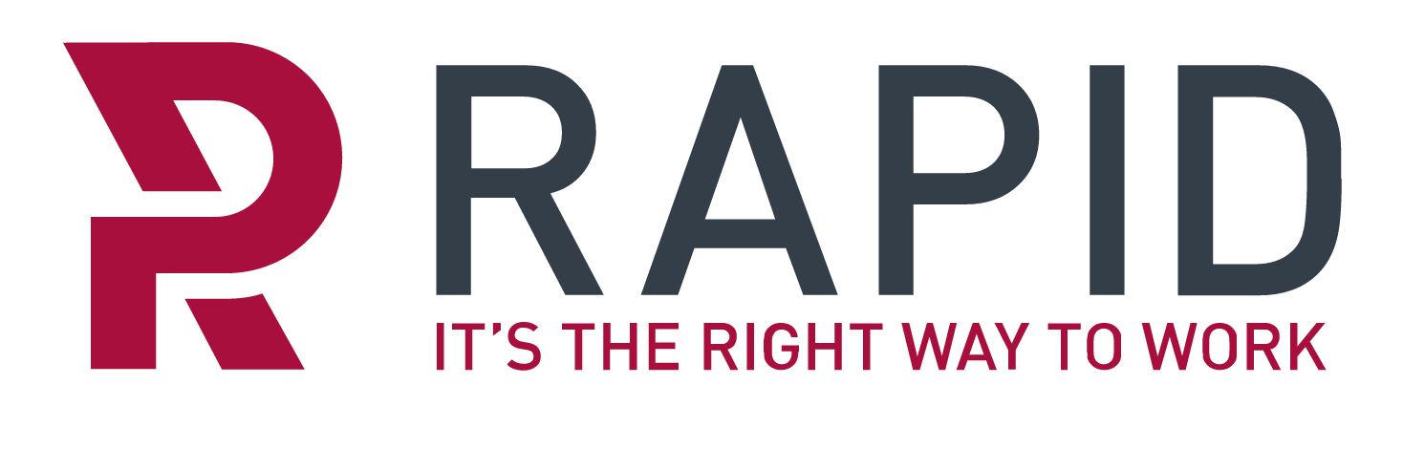
Lisa Street
Tracy Hulatt
Hep Oils Ltd (www.hepoils.com)
Julie Farel & Stacey Millsom
The Ready Family
The Jackson-Clutton Family

Lincs Forage (www.lincsforage.com)
Ann and Ed Sykes-Brennan
Jade Park-Ross
Mrs K Rogers
Mrs M Shoolheifer
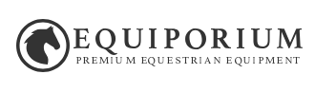



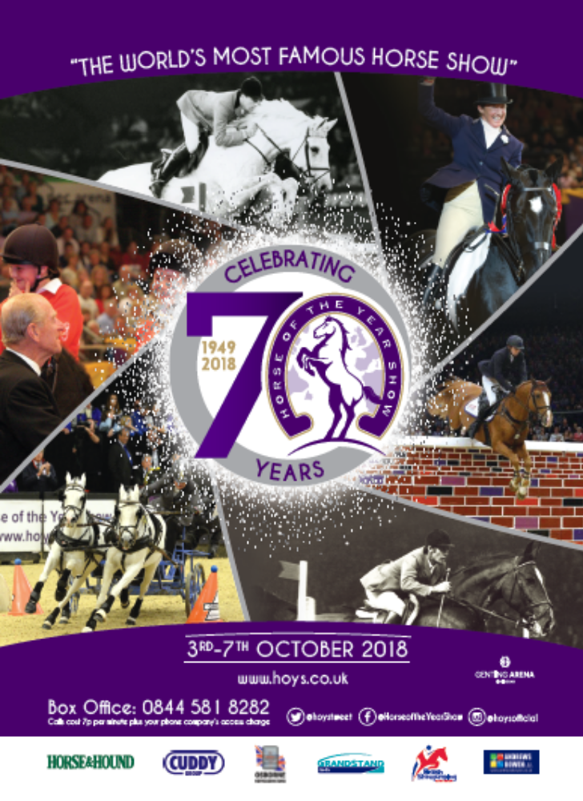
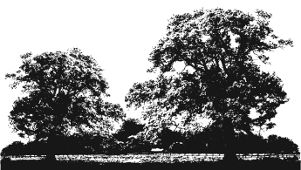
BSPS AREA 15a
Entries Secretary:
Mrs B Davis
Oakdene, Springwell Lane,
Harefield, Middlesex,
UB9 6PG
Tel: 01895 823576
Mob: 07960 639577

MID-HERTS COUNTRY SHOW

Sunday 22nd July 2018

HOYS qualifiers: £36; Olympia qualifiers £25; All other classes £15
The Mid-Herts Country Show

ALL HOYS ENTRIES MUST BE ACCOMPANIED BY A HOYS QUALIFIER ENTRY FORM
Entries Close: 10th July
Late entries/entries on the day accepted: HOYS qualifiers £50; Olympia qualifiers £40; All other classes £20

Office Use | Class | Name of Horse & Registration No. | Height | Name of Exhibitor & Registration No. | Name of Rider & Registration No. | Entry Fee

Name: ______________________________________________________________________________________ First Aid contribution per rider £5: __________________

Address: ____________________________________________________________________________________ Total Fees: __________________

_____________________________________________________________________________________________ Please make cheques payable to BSPS Area 15a

Tel: _________________________________________________________________________________________ I agree to comply with the conditions of the show

Email: _______________________________________________________________________________________ Signed: ______________________________ Date: ____________

